Title of Paper | Fire Standards Progress Report
Decision or Information | For information
Title and Date of Meeting | Fire Commission Meeting - June 10th, 2022
Attachments | None

Summary
This paper provides members of the Fire Commission with a summary of the progress on the Fire Standards. The Fire Standards Board last met formally on 8th December 2021, held a workshop in February 2022 and they next meet formally on 15 June 2022.

Recommendations
Members are asked to:
- note the contents of this report for information;
- provide ongoing support to officers in enabling and empowering them to engage in the development and implementation of the Fire Standards both in production and when published; and
- encourage the monitoring of the benefits of the Fire Standards in their services.

Current Status
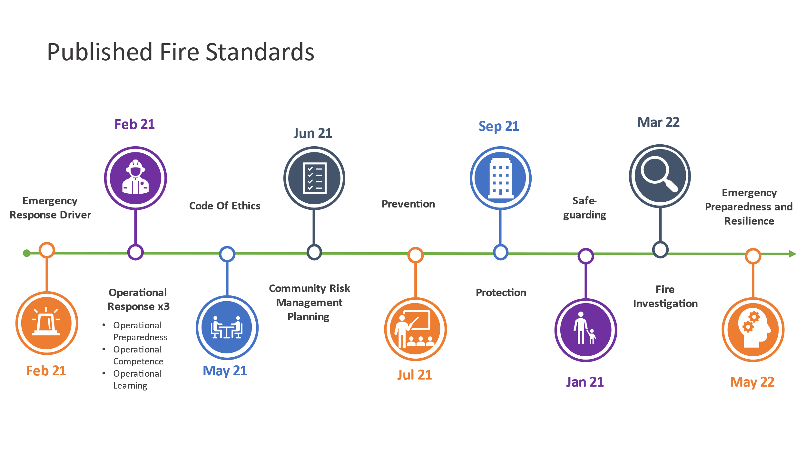There are now eleven approved and published Fire Standards which are available on the Fire Standards Board (FSB) website and shown in the timeline figure below.
The second phase of Fire Standards development is progressing with the remaining standards underway shown on the timeline diagram below, with a summary of the current status by standard:

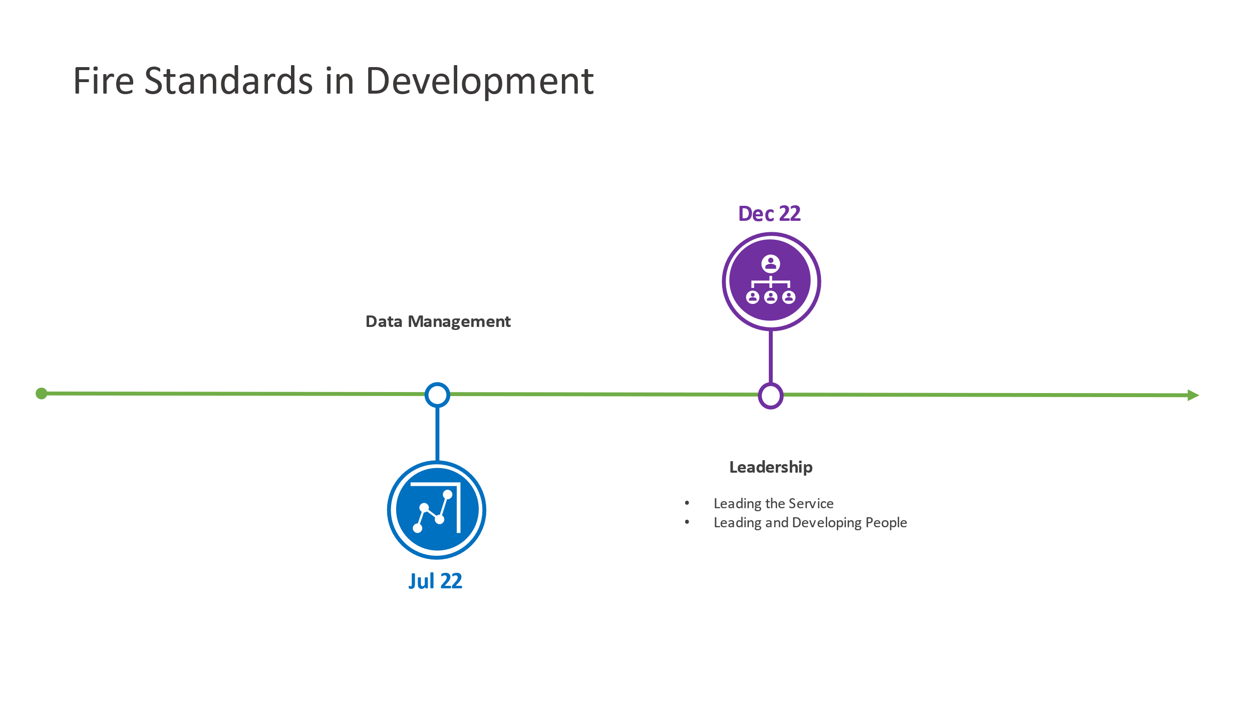

Development Update
Emergency Preparedness and Resilience
- Consultation on this standard completed in February 2022.
- Quality Assurance will be completed 23rd May and submitted to FSB for final approval.
- Published 31 May 2022.
Data Requirements and Management
- Consultation on this standard completed in May 2022.
- Analysis of the consultation responses took place during May to agree any revisions.
- It is anticipated the post-consultation standard will then be shared with FSB for approval for quality assurance in June 2022.
- Expected publication by July 2022.
Leadership and People Fire Standards
- Following a period of development and peer review, it has been agreed two complementary Fire Standards would be developed to cover the following;
  - Service Leadership (formerly “well-led” organisation) – setting out what an organisation that is well-led would look like and responsibilities and expectations of operational leaders
  - Leading and Developing People – setting out what good recruitment, development and management of people looks like to achieve a competent and motivated workforce

Draft Fire Standards were considered by the board and the peer group during February and March 2022, the conclusions of which were that further revisions would be required.
- Revision work is underway along with benchmarking against leadership industry standards aiming to produce pre-consultation drafts by June 2022.
- Consultation is then anticipated to commence by the end of June.
- Subject to consultation feedback, it is expected these standards will be published by December 2022.

Remaining Areas for Consideration
A third phase of development work is currently being scheduled, the figure below shows the areas being considered for possible Fire Standards. The areas in red are being addressed through the Leadership and People Fire Standards.
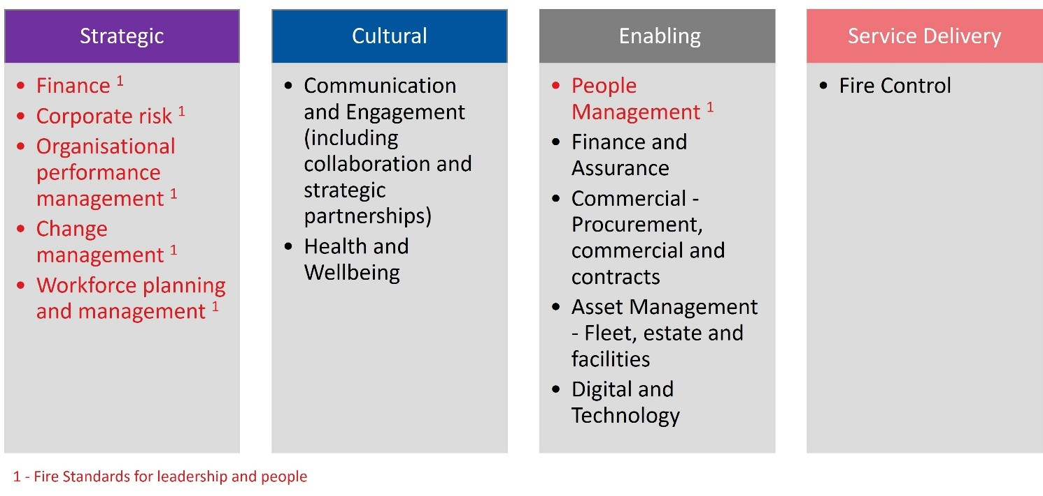It will not necessarily follow that a single Fire Standard will be developed for each activity listed above, but these are the areas of activity that remain outstanding. Discovery work and research in each area will help clarify and confirm what standards may be developed in a third phase. Proposals will be made to the FSB in June 2022.
It is anticipated that the full suite of standards will total approximately 21.
The FSB has a defined periodic review process in place following publication of a Fire Standard but can initiate an exceptional review should the need arise.

Implementation support
The FSB, through the NFCC Fire Standards and Implementation Teams, will be continuing to support services as they work to achieve the Fire Standards. Implementation tools are provided with all published Fire Standards.

Impact and Benefits Realisation
The FSB are keen to understand the impact of the Fire Standards now that the first standards have been published. As part of both the development process and the consultation on each Fire Standard we ask services about potential impacts.
The FSB will be undertaking engagement activity with services during the summer 2022 to help better understand impacts and review progress to date.

Background notes for information
The Fire Standards Board (FSB) is responsible for the identification, organisation, development and maintenance of professional standards for fire and rescue services in England. Led by an independent Chair and Vice Chair, membership of the Board includes the NFCC, employers (both the LGA and the APCC) and the Home Office.
The LGA representative on the Board is Cllr Nick Chard.
The FSB continues to meet regularly to review the progress made on Fire Standards development. Its next meeting is scheduled for 15 June 2022.
Given the various stages of development required and the time needed for engagement with services in the early stages, as well as through formal consultation, development work and publications are staggered. This is primarily done to align capacity and resources in a considered way, but also to pace the rate at which standards are released to services.
Once approved, Fire Standards are shared on the Fire Standards Board website.
Services should now be aware of the requirements being placed upon them through these Fire Standards. Her Majesty’s Inspectorate of Constabulary and Fire and Rescue Services (HMICFRS) will be referencing the standards in their inspection arrangements and therefore services should be prepared to evidence their progress towards achieving them.
The Fire Standards Board would welcome and appreciate the support of fire authority chairs and members in:
- Ensuring their services are enabled to engage in Fire Standards by releasing their subject matter experts to support development work and peer review through the NFCC where appropriate and feasible.
- Responding to the Fire Standards consultations as they are published; and,
- Supporting activities to achieve those Fire Standards through implementation once approved and published.

